

InfoClique

Physician Manual

Training and Education Services, IST Division

Course Summary

InfoClique is a web-based system designed to provide a secure central access point for patient information. This service is provided free in support of our patient care partners.

The InfoClique course is designed to familiarize physicians and physician support staff to the features of the InfoClique.

Course Prerequisite

It is recommended that all participants have basic Windows skills and a working knowledge of the Internet. Training & Education Services offers courses in both Windows 95/NT and Introduction to the Internet and KaleidaScope.

TABLE OF CONTENTS

What is InfoClique Physician? 2
How do I access InfoClique? 3
Changing Your Password 4
Physician Access 5
The Related Patient Section 6
Viewing a Patient’s Demographic Information 7
Viewing a Patient’s Flow 8
Viewing a Patient’s Dictated Reports 9
Viewing a Patient’s Orders 10
Viewing a Patient’s Results 11
Viewing a Patient’s Medications 13
Viewing a Patient’s Lab Report 14
The Visit List Section 15
The Surgery Scheduling System 16
Non-related Patients Section 17
Search Non-Related Patient Information by Last Name/First Name 18
Search Non-Related Patient Information by number 19
Account Maintenance 19
Edit Coverage Group 19
Overview Log 19
Change Password 19

What is InfoClique Physician?



Physician, Network Physician and Physician Support Staff View – Available patient data includes: results, orders, medications, demographic and insurance data, as well as dictated reports and surgery scheduling information. This information is displayed according to the patient/physician relationship (admitting, attending, referring or consulting).

How do I access InfoClique?

Once you have an assigned User Name and Password, you will be able to access InfoClique.

There are two methods for gaining access to InfoClique:

Method One – Accessing from within the Kaleida Network:
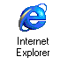

Double-click the Internet Explorer icon on your desktop.

If KaleidaScope is not displayed, type KaleidaScope in the address bar and press Enter.

Click the Applications link at the top of the KaleidaScope window.

- Enter your assigned User Name and Password, then click the Login button.

- After reading the security notice, click the Accept button.

- If this is your first time signing in, you will be asked to change your password. Please see page 5 for further information regarding changing passwords.

- Choose the appropriate InfoClique link from your list of applications.

Method Two – Accessing from any Internet-connected computer:

Double-click the Internet Explorer icon on your desktop.

Type https://www.infoclique.com in the address bar and press Enter. Please note that the “s” after http is required.

- Enter your assigned User Name and Password, then click the Continue button.

- After reading the security notice, click the Accept button.

- If this is your first time signing in, you will be asked to change your password. Please see page 5 for further information regarding changing passwords.

- Choose the appropriate InfoClique link from your list of applications.

Changing Your Password

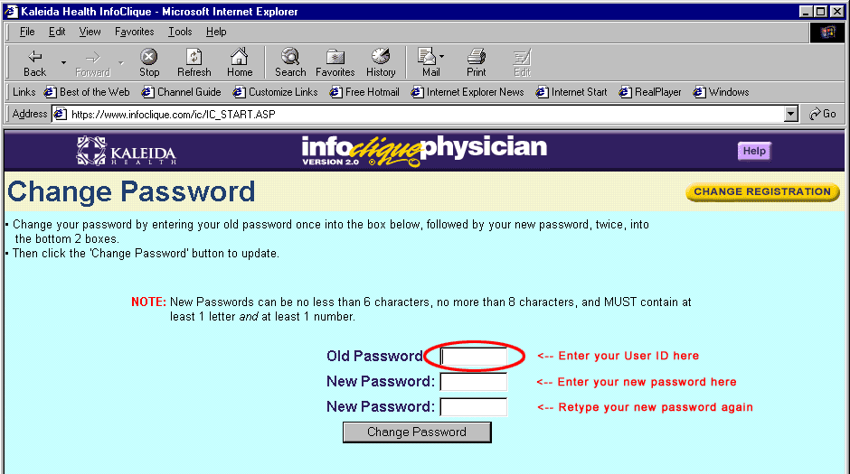
Step 1
Step 2
Step 3
- Type your User ID in the Old Password field.

- Type a new password in the New Password field. Passwords must be 6-8 characters in length and contain at least one number.

- Type your new password in the New Password field to verify your typing.

- Click Change Password after completing the three fields.

- Click Continue.
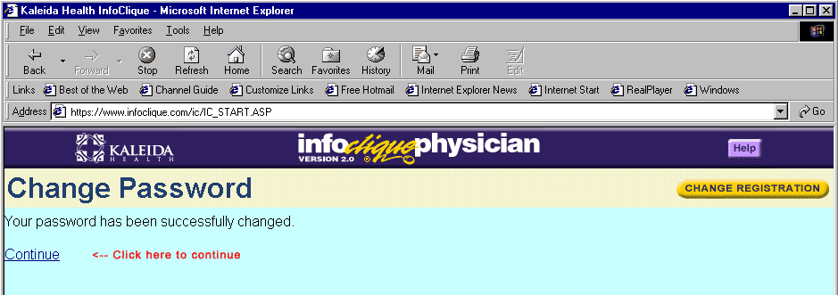

Physician Access

There are several ways that a physician can access patient information. The first is by using the Related Patient Section (circled below).
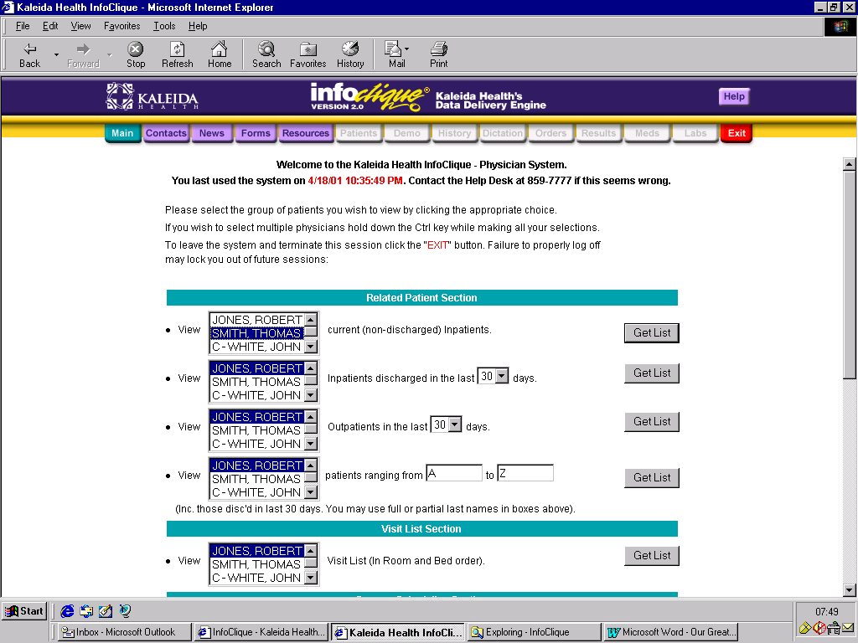

The Related Patient Section

This section allows you to generate a list of patient information. Patients will appear on your list if you are the attending, admitting, referring, or consulting physician for this encounter.

- Select the group of patients you wish to view and click Get List.
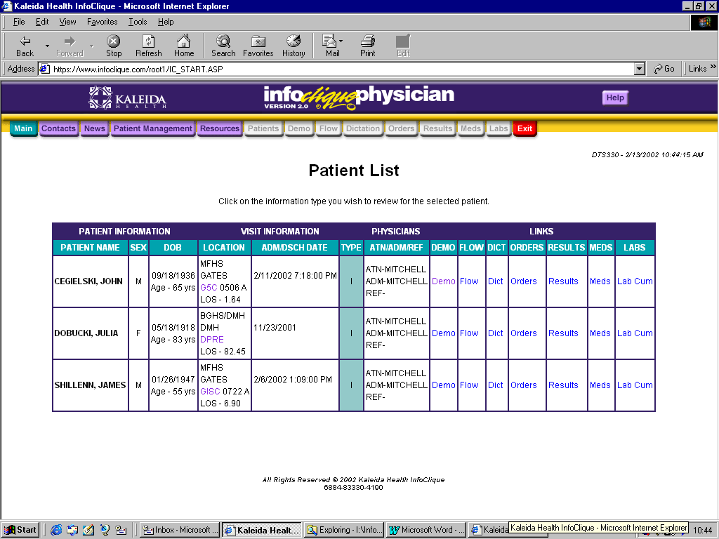
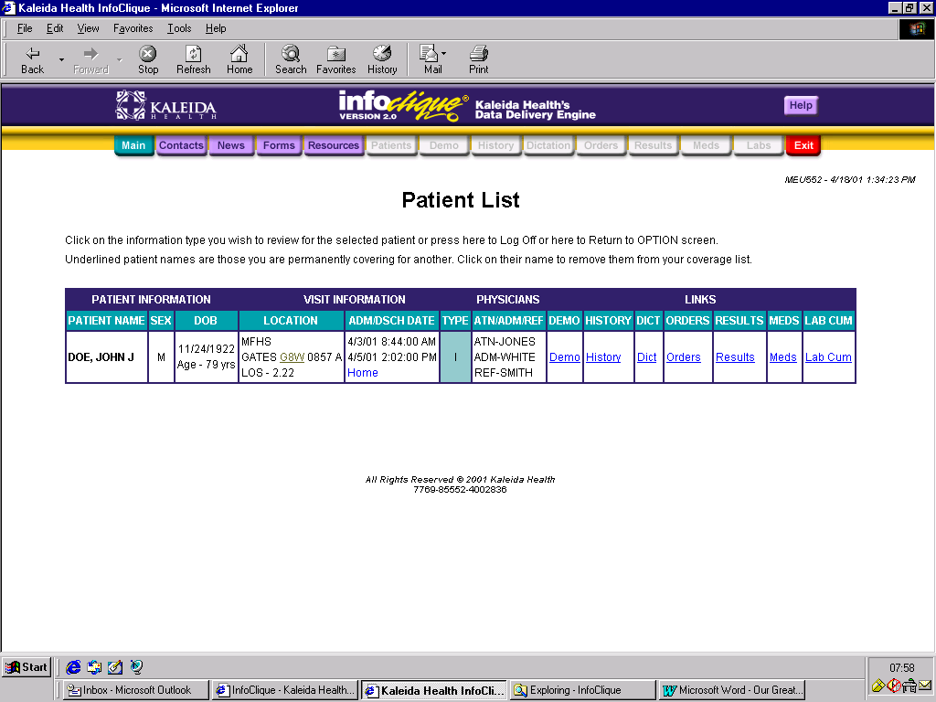

- Click the underlined option for view specific information for your patient. You have the ability to view a patient’s Demographic Information, Flow, Dictated Reports, Orders, Results, Medication and Labs.

Viewing a Patient’s Demographic Information

The demographic information available includes: Name and Address Data, Visit Data, Emergency Contact Data, Guarantor Data, Insurance Data, Physician Data and Allergy Data.

- Click Demo in the Links Section. You will see the following screen containing the patient’s demographic information:

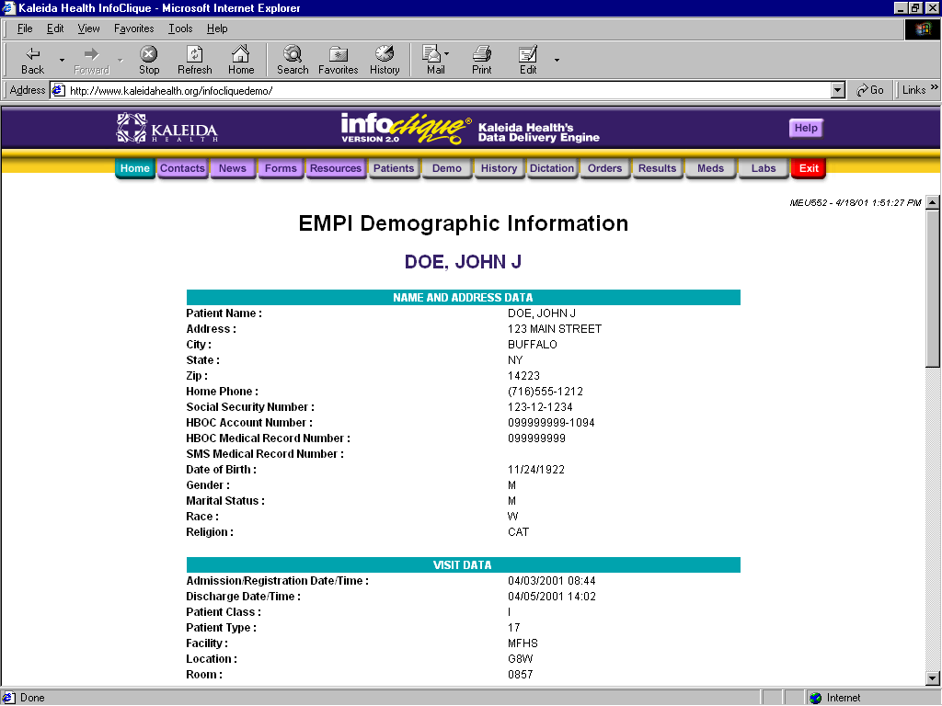
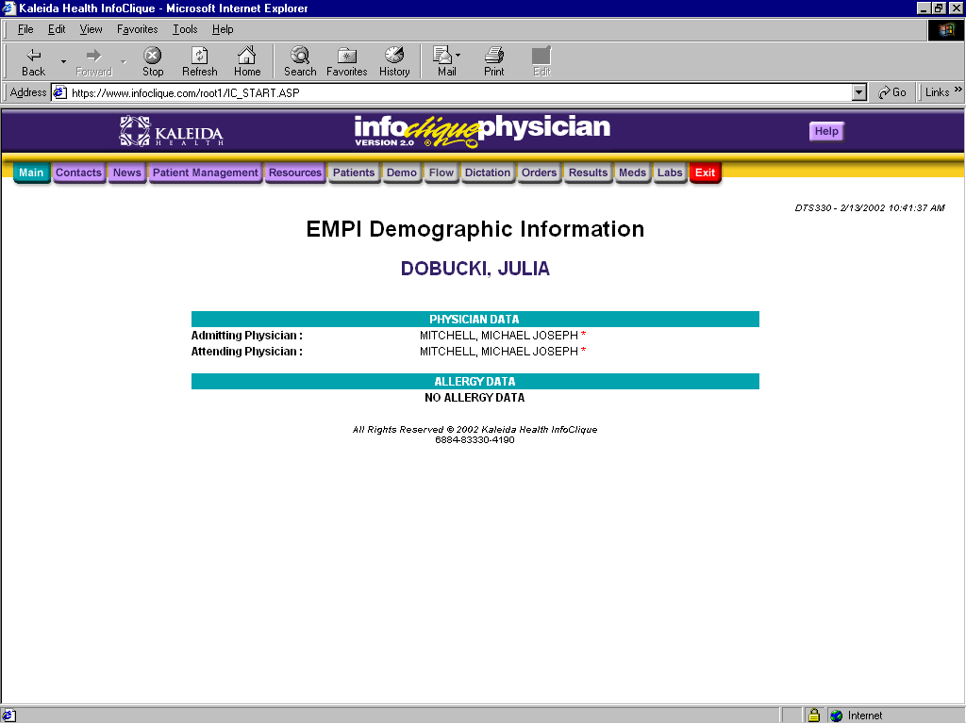

- Scroll through the information using the scroll bar on the right.

- You can advance to other areas regarding this patient by clicking the appropriate tab at the top of the page, or return to see other patients by clicking the Patients tab at the top of the page (see picture above).

Viewing a Patient’s Flow

The Flow information includes any admission, transfer and discharge dates and times, as well as the patient’s current/previous room and the patient type.

- Click the Flow tab to see the following screen:

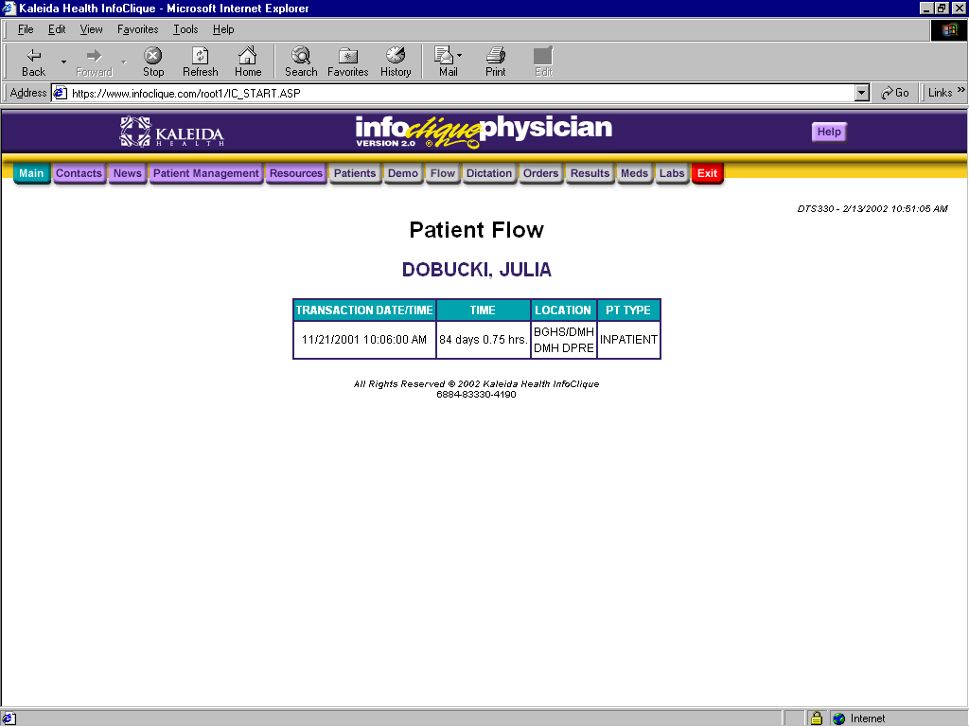

Viewing a Patient’s Dictated Reports

All Dictated Reports should be considered unverified.
InfoClique can access the dictated reports from the main dictation servers at BGH, CHOB, Gates and Suburban.
There are many specialized servers that are not accessible. To get dictated reports from those servers please follow normal procedures (phone call, etc).

- Click Dictation. You will see a screen similar to the following:

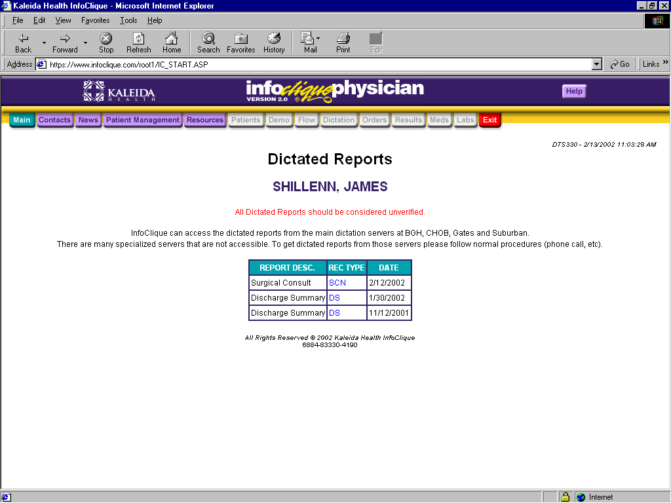

- Click the blue link that corresponds to the report you wish to view.

- Use the scroll bar to view the entire report.

- If you need to print this report, click the printer button on the toolbar. You can also print this by clicking on File and Print.

Viewing a Patient’s Orders

The Orders view provides information regarding all orders placed on a particular patient. You will be able to see the order number, the department category for that order, the order name, the status of the order, as well as the details regarding that order (priority, etc.

- Click Orders. You will see a screen similar to the following:
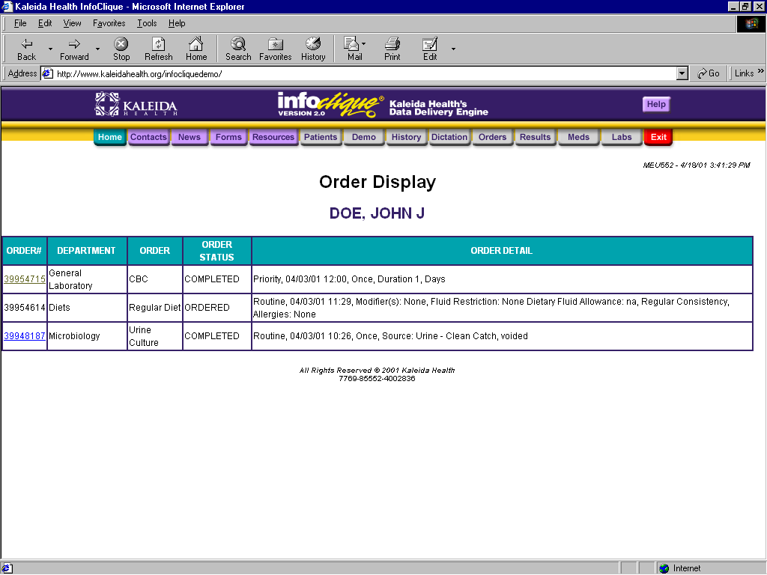

- To see the results of a completed order, click on the order number.

Viewing a Patient’s Results

The results screen displays all completed orders.

- Click Results to see a list of the patient’s results. You will see a screen similar to the following:
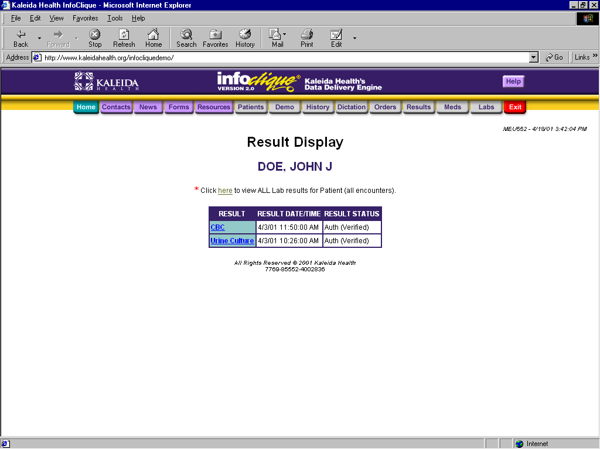

- Click on the result to view results details.
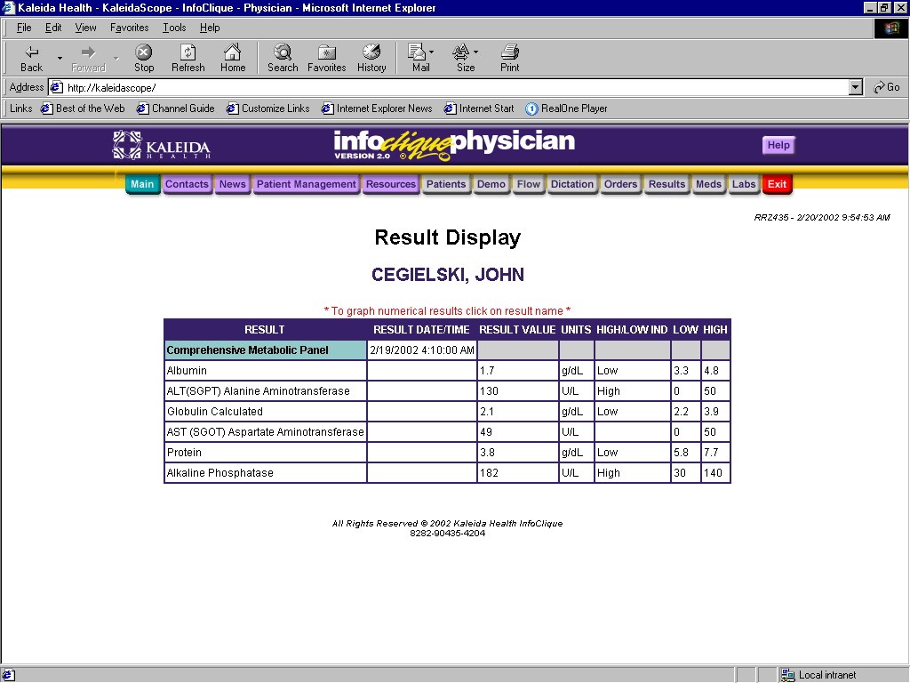

Viewing a Patient’s Results

In the detail results grid, you have the ability to graph numeric discrete results. Click on the discrete result name and a graph of the last 100 points will be produced. This graph crosses encounters.
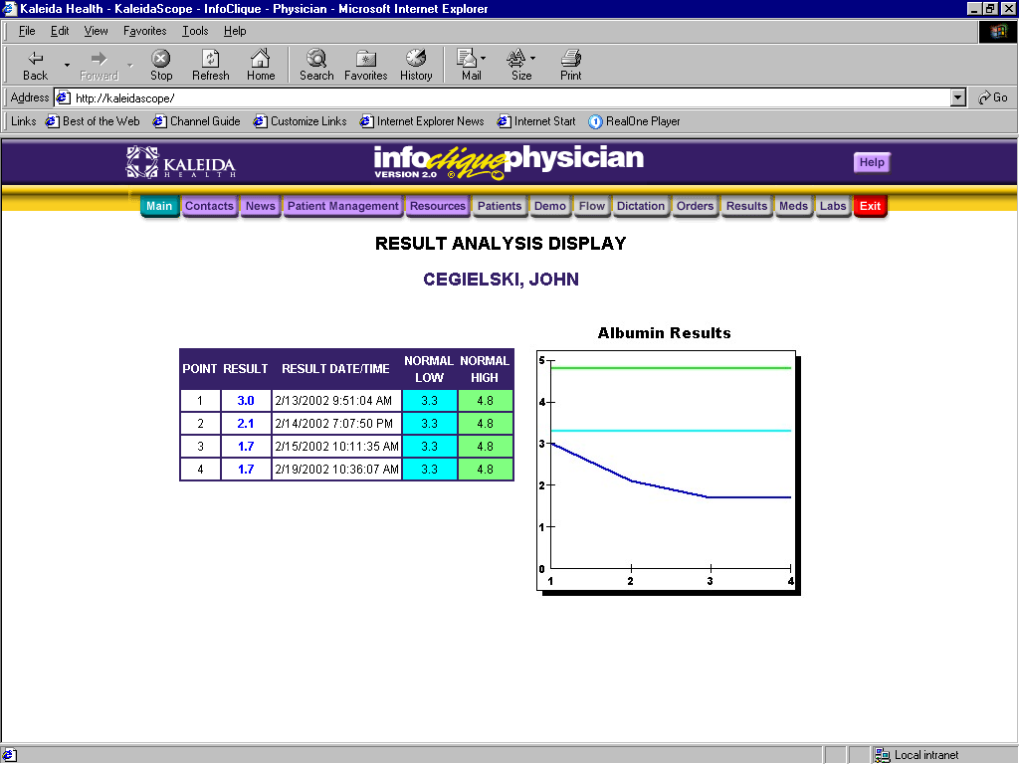
DOE, JOHN

- After viewing (or printing) the results, click on the Results tab again to view results for additional orders.

Viewing a Patient’s Medications

The medication view shows a list of all ordered medications for the patient. You will see medications that the patient is currently receiving, as well as discontinued medications.

- Click Meds. You will be brought to a screen similar to the following:
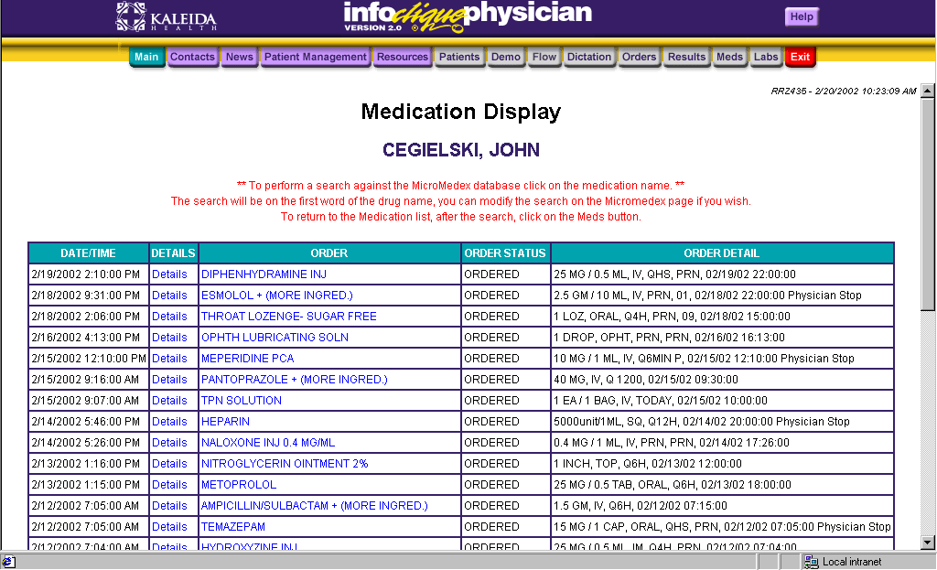
DOE, JOHN
- To view details on the medication, click on details. Start and stop information and ingredients will be shown.

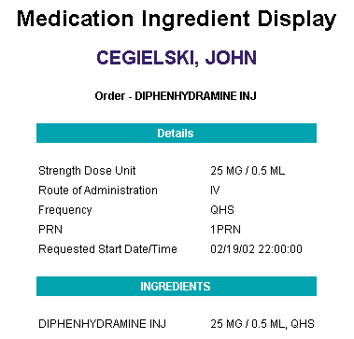
John Doe

Viewing a Patient’s Lab Report

You can access a report suitable for printing through the Lab Cum function.

- Click Lab. You will see a report similar to the following:

DOE, JOHN J
Kaleida Health Center for Laboratory Medicine
Department of Pathology
3 Gates Circle 115 Flint Rd. 1540 Maple Rd.
Buffalo, N.Y. 14209 Williamsville,N.Y. 14221 Amherst, N.Y. 14221
(716)887-4700 (716)626-7200 (716)568-3700
________________________________________________________________________________________________________
PATIENT: DOE, JOHN MED REC NO: (00000)00000000 LOCATION: G5C 0506A
PHYSICIAN: SMITH MICHAEL JOSEPH FINANCIAL NO: 000000000-0000 PRINTED: 13FEB02 0306 HRS.
RECEIVED: 12FEB02 0836 HRS.
------------------------------------------------------------------------------------------------------------
CHEMISTRY
------------------------------------------------------------------------------------------------------------

DATE 12FEB02
TIME 0836
PROCEDURE UNITS REF RANGE
BUN MG/DL (5-27) @ 12
CREATININE MG/DL (0.6-1.5) @ 1.3
BUN/CREAT (10.0-20.0) @ 9.2L

- To print this report, click Edit (on the menu bar), Select All. Then click on File, Print.

The Visit List Section

- Select the group of patients/facility you wish to view and click Get List. The list will be sorted by facility, then room and bed. This can be utilized as a rounds list.

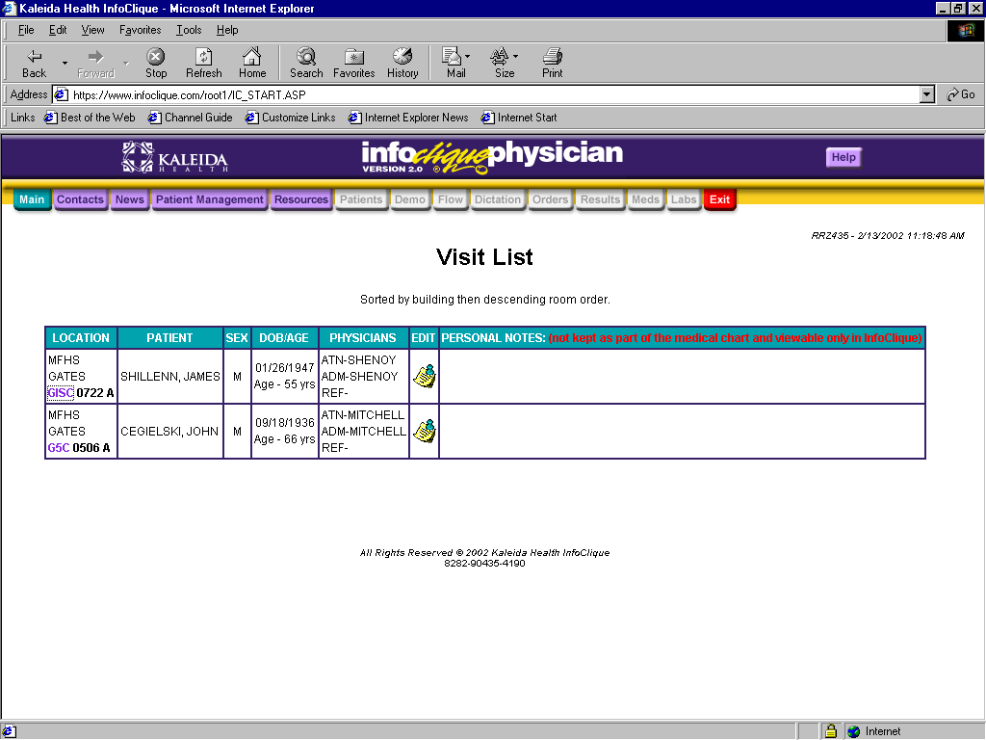

John Doe

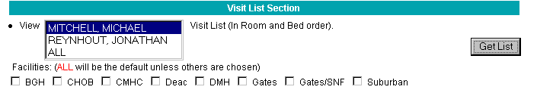
- Click on the underlined location to obtain more detailed information on the location, ie; phone numbers.

- Click on the note icon, under the Edit column to takes notes on a patient. Please note that these are not kept as part of the medical chart and viewable ONLY in InfoClique.

The Surgery Scheduling System

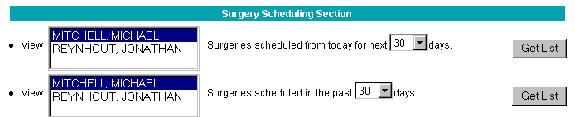

- Select the surgery schedule you wish to see. You can view the surgery schedule for today and up to 180 days into the future, or surgeries scheduled up to 180 days previous to today. Then click on the Get List button.

- You will see the surgery schedule as shown below.
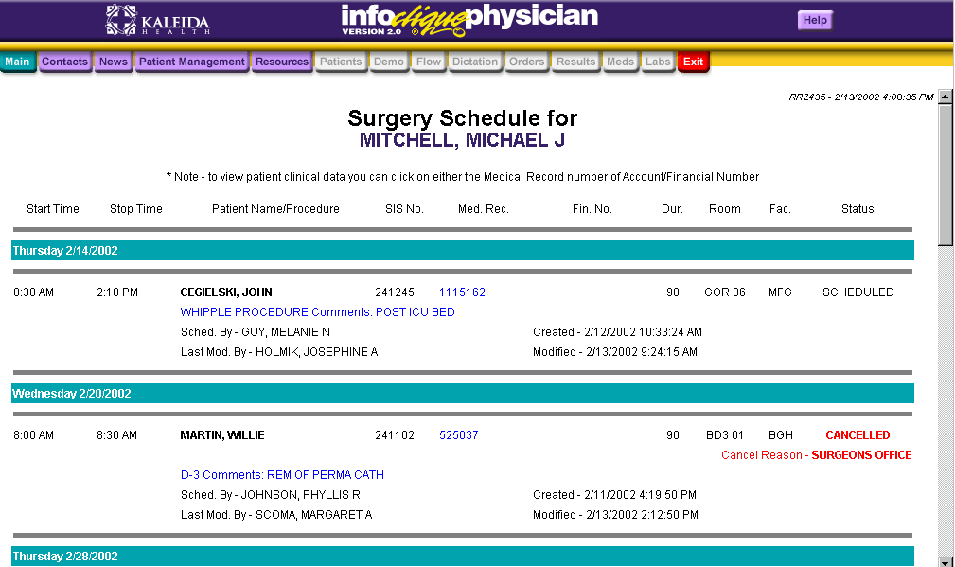
DOE, JOHN
SMITH, MICHAEL
DOE, JANE

- Here you may view all of the pertinent information regarding your surgery schedule.

- To view patient clinical data you can click on either the Medical Record number of Account/Financial Number, if there is a link available.

Non-related Patients Section

In the non-related Patients Section of InfoClique, you will have three choices:

- Search non-related patients of another physician
- Search non-related patients by last name/first name
- 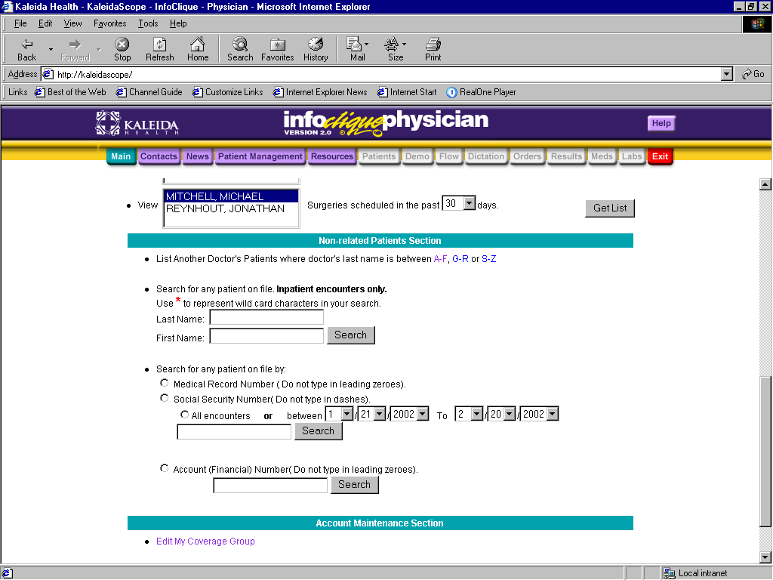Search non-related patients by MRN, financial number, or social security number

Search Non-Related Patient Information by Physician List

- Under the Non-related Patient Information section click on the appropriate letter range of the physician list you wish to view.
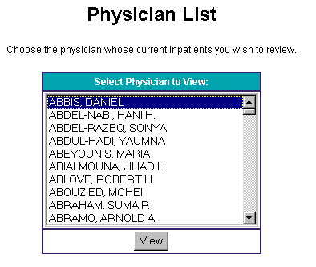

- Choose the physician whose current inpatients you wish to review.

- Click on the View button.

Search Non-Related Patient Information by Physician List

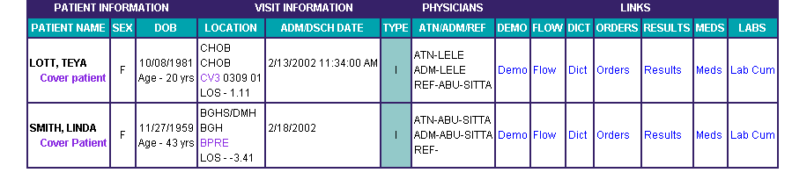

J. Doe

J. Doe

- Click the underlined option for view specific information for your patient. You have the ability to view a patient’s Demographic Information, Flow, Dictated Reports, Orders, Results, Medication and Labs.

Note: The view of patient data is set up the same as the Related Patient Information section. (pages 8 – 14)

Search Non-Related Patient Information by Last Name/First Name

- Under the Non-Related Patient Information Section, type in the Last Name or First Name of the patient you wish to locate and click on the Get List button.
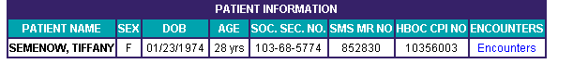
Jane Doe

- Click on Encounters to view patient’s Demographic Information, Flow, Dictated Reports, Orders, Results, Medication and Labs.

Search Non-Related Patient Information by number

- Under the Non-Related Patient Information Section, type in the Medical Record Number, Financial/Account Number, or Social Security Number of the patient you with to view. If you choose to view patient information by Medical Record Number or Financial/Account Number, you will have the option of viewing all encounters or specifying a date range.

- Click on the Get List Button.

- Click the underlined option for view specific information for your patient. You have the ability to view a patient’s Demographic Information, Flow, Dictated Reports, Orders, Results, Medication and Labs.

Account Maintenance

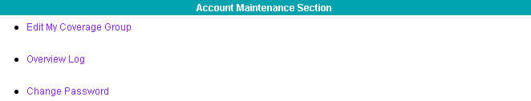

Edit Coverage Group

Click the Edit Cover Group link under the Account Maintenance section to temporarily assign yourself to another physician’s patients or to remove this coverage.

Overview Log

The Overview Log will allow you to see who is looking up information on your patients. This feature is currently not available.

Change Password

- Click the Change Password link to reset your password.

- Refer to the Change Password section of this manual and follow the steps listed on page 5.

